SOFTWARE PROJECT 2
Project 1 — Descriptive Analytics
Understanding a Diamond Retailer's Inventory
Dataset: diamonds (53,940 records)
Prepared by: dhanesh kumar
Course: software project
Date: July 9, 2026

1. Introduction & Business Objective
A jewelry retailer holds a catalogue of roughly 54,000 diamonds and wants to understand what it actually has in stock before making pricing or merchandising decisions. This project applies descriptive analytics — the branch of analytics concerned with summarizing and explaining what the data already shows, rather than forecasting the future (predictive) or recommending an action under constraints (prescriptive) — to answer two questions: what characteristics drive a diamond's price, and does the catalogue naturally divide into distinct product segments that could inform a tiered merchandising strategy?

2. Dataset Description
The analysis uses the public "diamonds" dataset (53,940 records before cleaning), which records each diamond's carat weight, the "4 Cs" of quality (cut, color, clarity), physical dimensions (length, width, depth in mm), and price in US dollars.
Column | Description
carat | Weight of the diamond
cut | Cut quality: Fair, Good, Very Good, Premium, Ideal
color | Diamond color grade, J (worst) to D (best)
clarity | Clarity grade, I1 (worst) to IF (best)
depth, table | Percentage measurements of the diamond's proportions
x, y, z | Length, width, depth in millimeters
price | Price in US dollars (target of interest)

3. Methodology

3.1 Importing Libraries and Loading the Data
pandas and numpy handle data manipulation, matplotlib/seaborn produce the visualizations, and scikit-learn provides feature scaling and the K-Means clustering model. The raw CSV is loaded into a pandas DataFrame and inspected for shape, column types, and a sample of rows to confirm it loaded correctly.

3.2 Data Cleaning and Preprocessing
The stray index column carried over from the source file is dropped. More importantly, 20 records have a physically impossible dimension of 0mm for length, width, or depth — these are data-entry errors (a diamond cannot have zero size) and are removed rather than imputed, since there is no reliable way to reconstruct the true measurement.

3.3 Duplicate Removal
145 exact duplicate rows are identified via pandas' duplicated() check and removed, leaving 53,775 clean records.

3.4 Feature Selection
The three physical dimension columns (x, y, z) are combined into a single derived volume feature (x × y × z). Carat and volume are highly redundant — both measure diamond size — so consolidating them avoids feeding near-duplicate information into the clustering model.

3.5 Encoding Categorical Attributes
Cut, color, and clarity all have a genuine best-to-worst order defined by gemological standards, so each is mapped to an ordered integer (e.g. clarity: I1=0 … IF=7) rather than one-hot encoded, which would discard that ordering information.

4. Exploratory Data Analysis
Carat correlates with price far more strongly (r ≈ 0.92) than cut, color, or clarity individually — size is the dominant driver of value. Interestingly, average price does not rise monotonically with subjective cut quality: larger stones are disproportionately cut to lower grades to preserve carat weight, so cut alone is a misleading price signal without controlling for size.
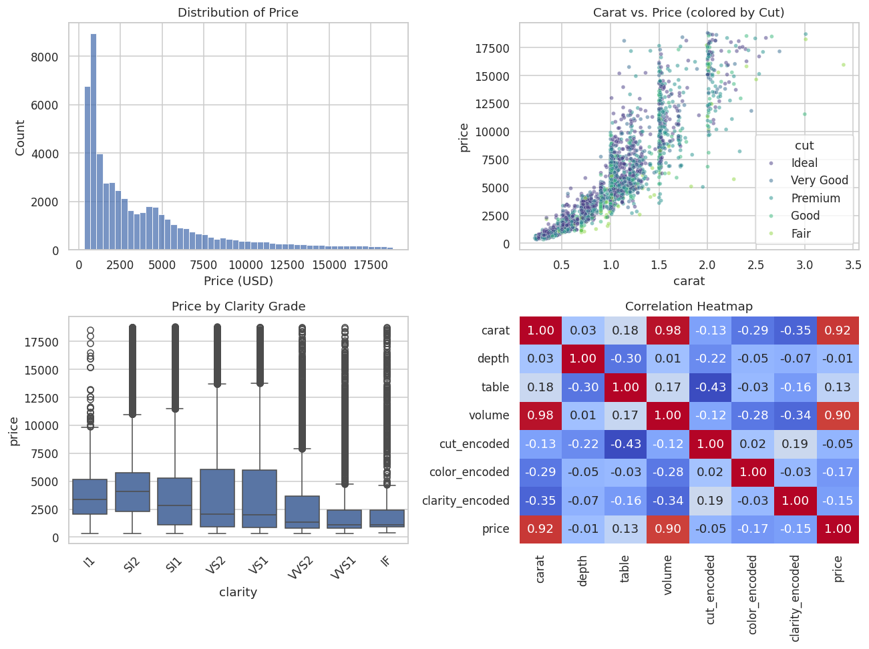
Figure 1. Price distribution, carat vs. price by cut, price by clarity, and the correlation heatmap.

5. Model Building & Evaluation
Descriptive analytics does not predict a future label, so rather than a supervised model, K-Means clustering is used to let the catalogue reveal its own natural groupings. Features are standardized first since K-Means is distance-based and would otherwise be dominated by whichever feature has the largest numeric scale (price, in raw dollars, would swamp the 0–7 encoded quality grades).
The silhouette score is statistically highest at k=2, but that only yields a crude "cheap vs. expensive" split with little merchandising value. k=4 retains a clearly positive, reasonable silhouette score (0.25) while giving the business four actionable tiers instead of two — a deliberate trade of a little statistical tightness for practical usefulness.
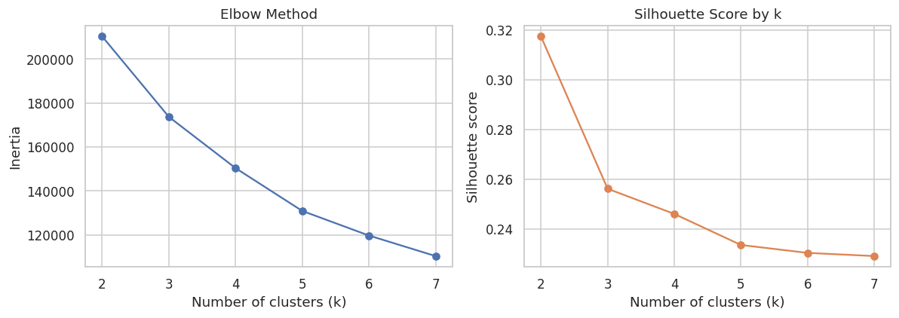
Figure 2. Elbow method and silhouette score across candidate values of k.
Segment | Avg. Carat | Avg. Price | Share of Catalogue
Everyday Essentials | 0.43 | $1,280 | 39.9%
Value Step-Up | 0.68 | $2,460 | 23.4%
Premium Statement | 1.06 | $5,560 | 25.0%
Luxury | 1.76 | $12,490 | 11.7%
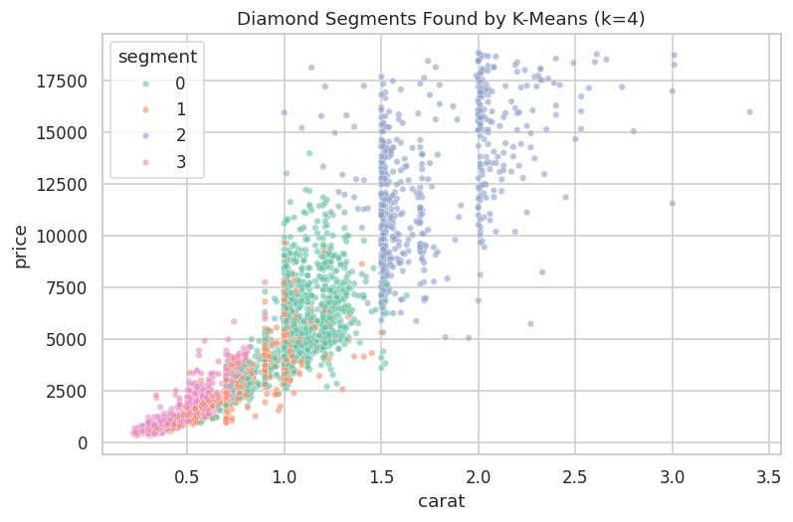
Figure 3. The four segments plotted by carat and price.

6. Results Interpretation & Discussion
- Everyday Essentials (~40% of catalogue): the volume core of the business — small and affordable, and notably the highest average clarity grade of any segment, suggesting the retailer competes on quality at accessible price points rather than on size.
- Value Step-Up (~23%): a mid-market bridge segment for buyers trading up from the entry tier.
- Premium Statement (~25%): meaningfully larger stones at a substantially higher price point.
- Luxury (~12%): the smallest group by count but, at roughly 10x the entry-tier price, very likely a disproportionate share of total revenue.
These four tiers give the retailer a ready-made, data-driven basis for tiered merchandising (e.g. "Essentials / Step-Up / Premium / Luxury" collections), differentiated pricing, and inventory planning — replacing assumptions about the catalogue with an evidence-based description of what it actually contains.

7. Conclusion
This project demonstrates a complete descriptive-analytics workflow: cleaning and encoding real retail data, exploring what drives price through EDA, and using unsupervised clustering to describe natural product segments. The resulting four-tier segmentation is directly actionable for merchandising and pricing strategy, and the cleaned, segmented dataset feeds naturally into further predictive or prescriptive work (Projects 2 and 3).

